Lesson 5 Demo 4: Snippet Generator

This section will guide you to:

* Generate a step snippet with the Snippet Generator

**Please Note**: This demo is incremental. Ensure you have completed the earlier demos

This lab has one sub-section, namely:

1. Generating Pipeline code with Snippet Generator

**Step 1:** Generating Pipeline code with Snippet Generator

* Navigate to the Pipeline Syntax link (referenced below) from a configured Pipeline, or at ${YOUR_JENKINS_URL}/pipeline-syntax.

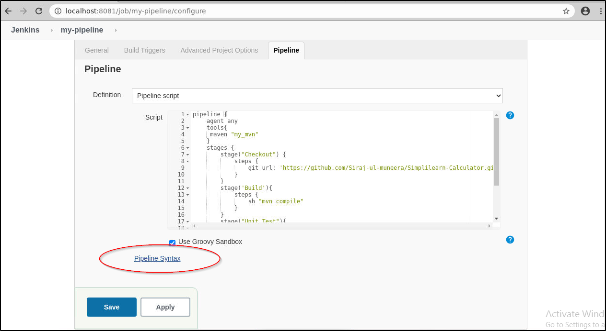

* Select the desired step in the Sample Step dropdown menu

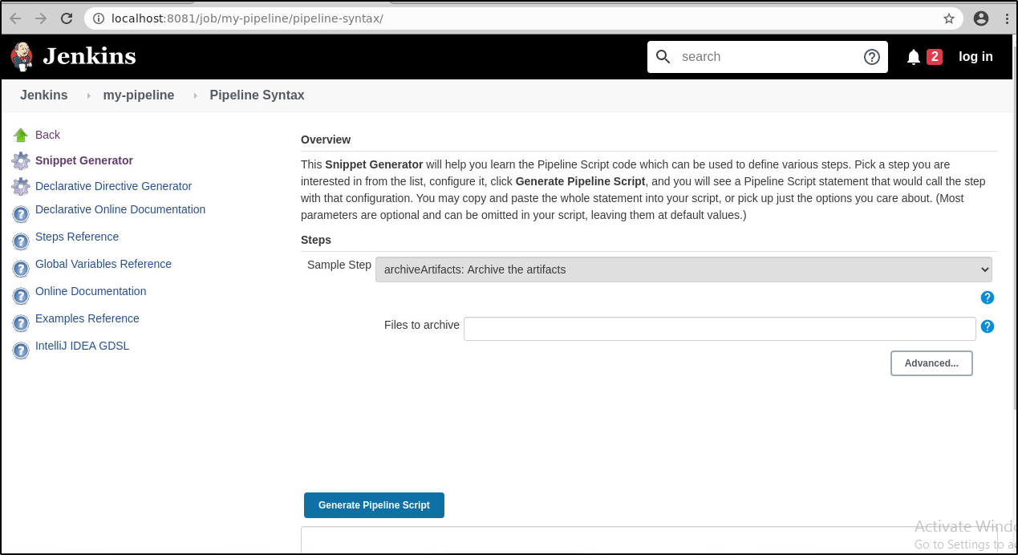

* Use the dynamically populated area below the **Sample Step** dropdown to configure the selected step.
* Click **Generate Pipeline Script** to create a snippet of Pipeline which can be copied and pasted into a Pipeline

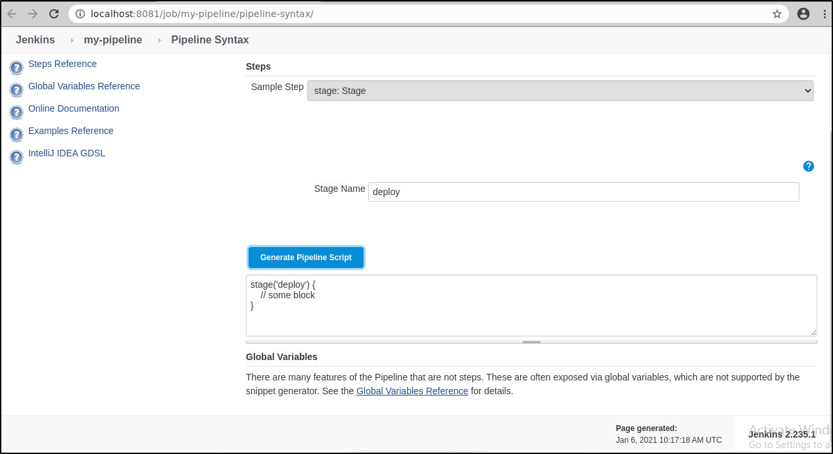

* To access additional information and/or documentation about the step selected, click on the help icon (question mark icon in blue).